**AIR QUALITY PREDICTION**



**FOR SMART CITIES IN INDIA**

**CERTIFIEDSPECIALISTINDATASCIENCE&ANALYTICS**

**MAINPROJECTREPORT**

**Submitted by**

**ANAGHASHARMA**

**ANAGHAP**

**KARTHIKARAJEEV**

**ROSEMOLSHAJI**

BuildingtheNations Future

**ICTACADEMYOFKERALA**

(A Govt. of Indiasupported, Govt. of KeralapartneredSocialEnterprise)

**CONTENTS**

1. DATA DESCRIPTION
2. INTRODUCTION
3. PROBLEM STATEMENT
4. EXPLORATORY DATA ANALYSIS AND DATA VISUALIZATIONS

4.1 Introduction

4.2 Importing python libraries

4.3 Loading the dataset

4.4 Checking basic information

4.5 Data Pre-processing

4.6 Data Visualization

4.6.1 Count Plot

4.6.2 Scatter Plot

4.6.3 Box Plot

4.6.4 Bar Plot

5. MODEL TRAINING AND EVALUATION

5.1 Introduction

5.2 Splitting data into Train and Test sets

5.3 Building various machine learning models

5.3.1 Multiple Linear Regression

5.3.2 Logistic Regression

5.3.3 KNN

5.3.4 Decision Tree Classifier

5.3.5 SVM

5.3.6 Random Forest

5.3.7 Gradient Boosting Classifier

5.3.8 Extreme Gradient Boosting Classifier

5.4 Conclusion

6. USER INTERFACE AND WEBSITE HOSTING

7. ADVANTAGES, DISADVANTAGES AND FUTURE SCOPE

8. CONCLUSION

9. REFERENCE

1. **DATA DESCRIPTION**

The data file contains 29531 observations and 16 attributes including 12 pollutants. The attribute information is provided below:

|  |  |
| --- | --- |
| **Variable Name** | **Variable Information** |
| City | Name of the city |
| Date | Dates ranging from 01-01-2015 to  01-07-2020 |
| PM2.5 | Particulate Matter 2.5-micrometer in ug / m3 |
| PM10 | Particulate Matter 10-micrometer in ug / m3 |
| NO | Nitric Oxide in ug / m3 |
| NO2 | Nitric Dioxide in ug / m3 |
| NOx | Any Nitric x-oxide in ppb |
| NH3 | Ammonia in ug / m3 |
| CO | Carbon Monoxide in mg / m3 |
| SO2 | Sulphur Dioxide in ug / m3 |
| O3 | Ozone in ug / m3 |
| Benzene | Benzene in ug / m3 |
| Toluene | Toluene in ug / m3 |
| Xylene | Xylene in ug / m3 |
| AQI | Air Quality Index |
| AQI Bucket | Air Quality Index bucket |

1. **INTRODUCTION**

Air is a core element for the sustenance of life. The cleaner the air, the better your health and well-being. However, various sources, especially anthropogenic, are posing a significant threat to air quality.

Air pollution is a major and growing risk factor for ill health in India, contributing significantly to the country’s burden of disease. As per the Global Burden of Disease comparative risk assessment for 2015, air pollution exposure contributes to approximately 1.8 million premature deaths and 49 million disability adjusted life-years (DALYs) lost, ranking it among the top risk factors for ill health in India. Rural and urban India are both affected by poor air quality. Air pollution thus has been termed a democratizing force but it is far from that, as it propagates existing environmental injustices. Studies have shown that children and the elderly are particularly vulnerable to air pollution exposure. Air pollution exposure has shown to slow lung development in children, affect cognitive development, and has resulted in high levels of mortality from respiratory infections. The elderly is more likely to develop chronic respiratory and cardiac illnesses as a result of long-term exposure, and are more susceptible to heart attacks and strokes during episodic high pollution events

In 2015, Government of India, together with [IIT Kanpur](https://en.wikipedia.org/wiki/IIT_Kanpur) launched the National Air Quality Index. In 2019, India launched 'The National Clean Air Programme' with a tentative national target of 20%-30% reduction in PM2.5 and PM10 concentrations by 2024, considering 2017 as the base year for comparison. It will be rolled out in 102 cities that are considered to have air quality worse than the [National Ambient Air Quality Standards](https://en.wikipedia.org/wiki/National_Ambient_Air_Quality_Standards).

Pollution is the greatest risk to human life, more so in India than in any other country. Air Quality Index (AQI) is a numerical scale used to measure and report air quality of an area on a given day. Eight pollutants namely PM10, PM2.5, NO2, SO2, CO, O3, NH3, NOx, Benzene, Toluene and Xylene are the major parameters taken into consideration while deriving AQI of a region. Public health risks increase as the AQI rises.

Central Pollution Control Board, a statutory organization under the Ministry of Environment and Forests, Government of India, provides air quality data and AQI at an hourly and daily basis of various stations across cities in India. By analysing the daily AQI data for different cities of India, it was found that Ahmedabad, Delhi, Patna, Gurugram, and Lucknow have the highest AQI values on an average daily basis for the year 2015- 2019.

1. **PROBLEM STATEMENT**

**“ To predict the Air Quality Index (AQI) using regression modelling and to develop a multi-class classification system which classifies cities based on their AQI range.”**

1. **EXPLORATORY DATA ANALYSIS ANDDATA VISUALIZATIONS**

**4.1 Introduction**

Exploratory data analysis (EDA) is used by data scientists to analyse and investigate data sets and summarize their main characteristics, often employing data visualization methods. It helps determine how best to manipulate data sources to get the answers you need, making it easier for data scientists to discover patterns, spot anomalies, test a hypothesis, or check assumptions.EDA is primarily used to see what data can reveal beyond the formal modelling or hypothesis testing task and provides a better understanding of data set variables and the relationships between them.

**4.2 Importing Python libraries**

The foremost step in EDA is to import the necessary libraries into picture. These libraries include pandas, NumPy, matplotlib and seaborn.

**4.3 Loading the dataset**

Second step is to import the dataset. This dataset contains 29531 observations and 16 attributes.

**4.4 Checking basic information and Data Pre-processing**

* **Data Head and Tail**

It displays the first and last five rows of the dataset.

* **Data shape**:

It shows the no of rows and columns present. This dataset has 29531 rows and 16 columns.

* **Data information**:

Gives information regarding different columns of the dataset along with non-null counts.

It provides a basic outlook of the dataset. Here we have 16 attributes and among them 13 of them are of float64 type and 2 are object type and 1 is of date type. It also provides the number of non null counts for each attribute. City and the Date columns are the only ones without any null values present and Xylene is having the highest number of null values.

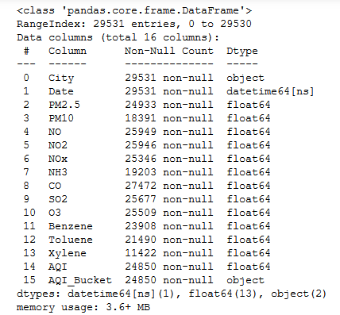

* **Data description**:

The describe () function in pandas is very handy in getting various summary statistics. This function returns the count, mean, standard deviation, minimum and maximum values and the quantiles of the data.

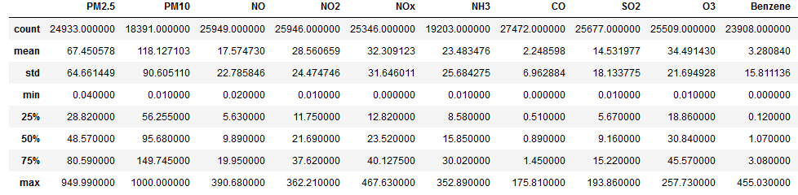

Here we can observe the different measures of central tendency.

* **Data types**:

Describes the type of the data (integer, float, Python object, etc.). Here all the pollutants are of float type. City and the AQI_Bucket are of object type and the date is recorded in datetime format.

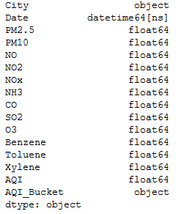

* **Data skewness**:

Skewness refers to a distortion or asymmetry that deviates from the symmetrical bell curve, or normal distribution, in a set of data.

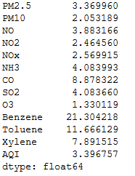

Here all the attributes are positively skewed.

* **Kurtosis of the data**:

Kurtosis is a statistical measure used to describe the degree to which scores cluster in the tails or the peak of a frequency distribution. The peak is the tallest part of the distribution, and the tails are the ends of the distribution. There are three types of kurtosis: mesokurtic, leptokurtic, and platykurtic.

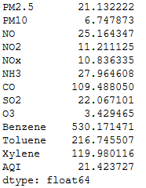

The distribution with kurtosis equal to3 is known as mesokurtic. A random variable which follows normal distribution has kurtosis 3.If the kurtosis is less than three, the distribution is called platykurtic. If the kurtosis is greater than three, the distribution is called leptokurtic.

Here, all the attributes are leptokurtic.

**4.5 Data Pre-processing**

* **Missing value detection**:

Real-world data often has missing values**.** Data can have missing values for a number of reasons such as observations that were not recorded and data corruption. Handling missing data is important as many machine learning algorithms do not support data with missing values.

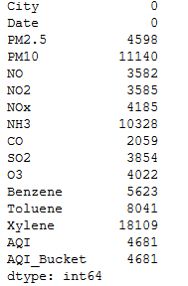

Here Xylene, PM10, NH3 have a large number of missing values.

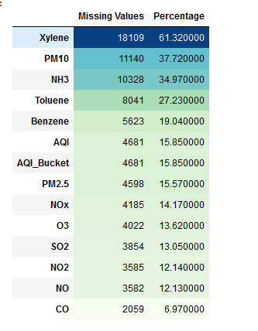

Since we are dealing with time series data, here we use imputation methods like linear interpolation and backward fill method to fill in the missing values of the pollutants and the AQI range.

**Linear Interpolation:** Linear interpolation is an imputation technique that assumes a linear relationship between data points and utilizes non-missing values from adjacent data points to compute a value for a missing data point.

**Backward Filling**: Backward filling means to fill missing values with the next data point.

For filling in the missing values of AQI_Bucket we developed a function that classifies the AQI_Bucket as good, satisfactory, moderate, poor, very poor and severe based on the AQI range.

* **Outliers Detection:** The data under consideration is having outliers in almost 10 variables. And this problem is sorted out using percentile method for outlier handling.
* **Label Encoding:**Label Encoding refers to converting the labels into numeric form so as to convert it into the machine-readable form. Machine learning algorithms can then decide in a better way on how those labels must be operated. It is an important preprocessing step for the structured dataset in supervised learning.

Here, the attributes named City and AQI Bucket are labely encoded.

* **Feature Engineering**: Feature engineering is a process of transforming the given data into a form which is easier to interpret. Here we performed this by combining particulate matters like PM10, PM2.5 as PM implying particulate matters and other pollutants like Benzene, Toluene and Xylene are also combined to a single attribute which is coined as others.

PM = PM10 + PM2.5

Others = Benzene + Toluene + Xylene

* **Determining correlation between attributes**

A correlation heatmap uses coloured cells, typically in a monochromatic scale, to show a 2Dcorrelationmatrix (table) between two discrete dimensions or event types. Correlation heatmaps are ideal for comparing the measurement for each pair of dimension values.

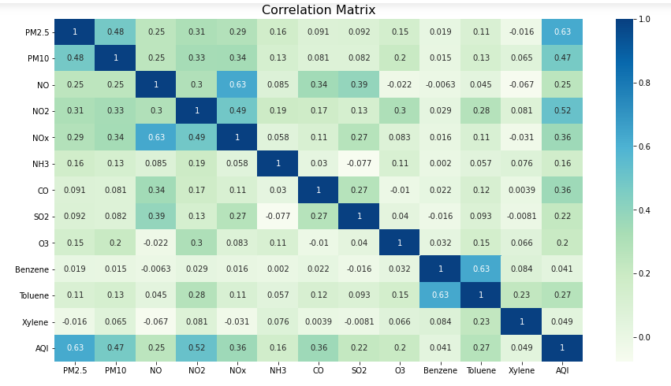

Here pollutants like PM2.5, NO2, PM10 exhibit high correlation with AQI range. Whereas pollutants like Benzene, Toluene, Xylene exhibit very low correlation.

**4.6 Data Visualization**

Data visualization is the graphical representation of information and data. By using visual elements like charts, graphs, and maps,data visualization tools provide an accessible way to see and understand trends, outliers, and patterns indata.Data visualization gives us a clear idea of what the information means by giving it visual context through maps or graphs. This makes the data more natural for the human mind to comprehend.

**4.6.1 Count Plot**

A count plot is kind of like histogram or a bar graph for some categorical area. It simply shows the number of occurrences of an item based on a certain type of category. countplot() method is used to Show the counts of observations in each categorical bin using bars. We can see that the target class that is the AQI_Bucket is balanced. So we are not having an unbalanced dataset. Classes like Satisfactory, Moderate, Good, Poor, Very Poor, Severe have approximately equal number of observations.

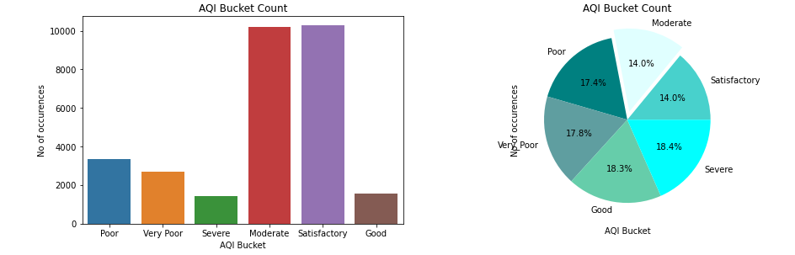

**4.6.2 Scatter Plots**

A scatter plot(also called a scatter plot, scattergraph, scatter chart, scattergram, scatter diagram) is a type of plot mathematical diagram using Cartesian coordinates to display values for typically two variables for a set of data.

Here we observed the growth rate of pollutants contributing to the air quality from 2015 to 2020.

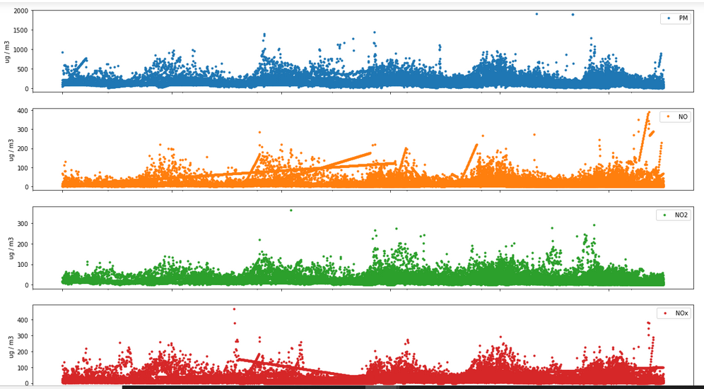

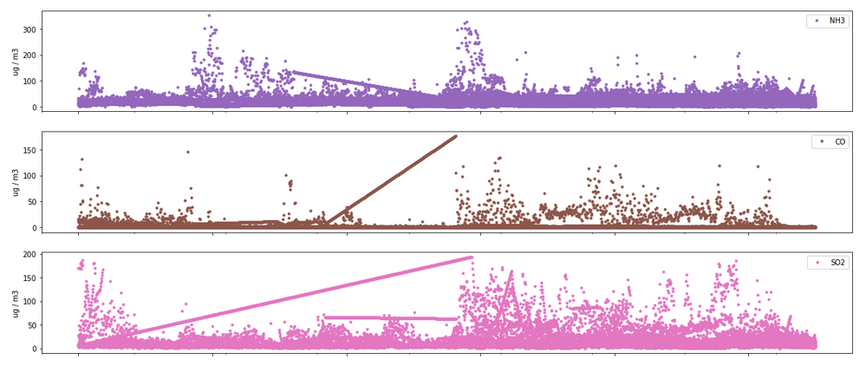

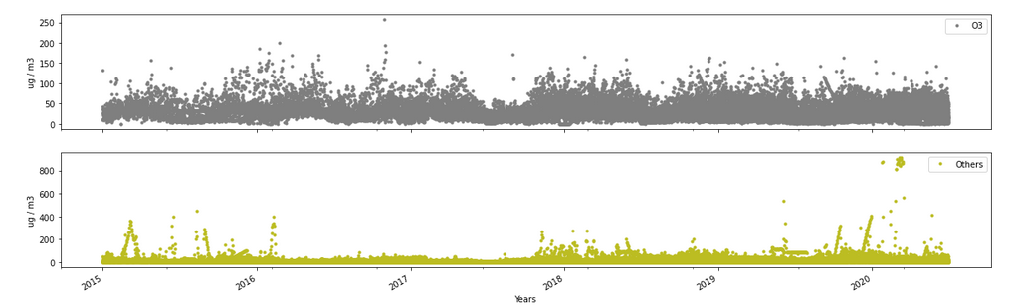

The particulate matter (PM2.5, PM10), NO, NOX show a rise in January-June and a decrease during July-December. There has been an increase in the sulphur dioxide (SO2) compound since 2017.For other particles like Benzene, Toluene and Xylene show a significant increase since 2018The presence of ozone is somewhat consistent throughout the years.

We can now observe how different pollutants are contributing to the air quality in different cities.

**Particulate matter - PM**

Particulate Matter is the sum of all solid and liquid particles suspended in air many of which are hazardous. This complex mixture includes both organic and inorganic particles, such as dust, pollen,soot, smoke, and liquid droplets. These particles vary greatly insize, composition, and origin. Particles in air are either directly emitted, for instance when fuel is burnt and when dust is carried by wind, or indirectly formed, when gaseous pollutants previously emitted to air turn into particulate matter.

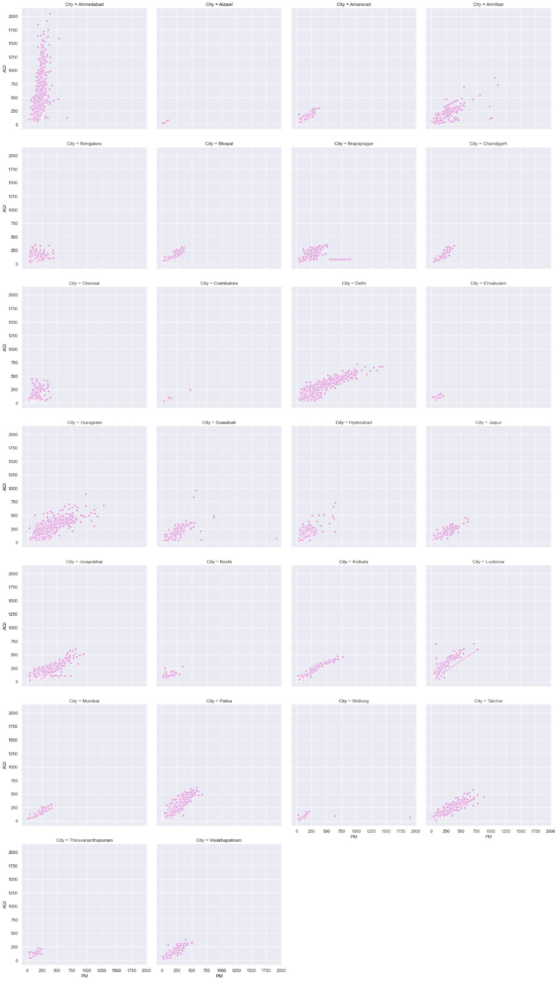

Ahmedabad is the city with high particulate matters and ernakulam with the least. We can see that in cities like Delhi, Gurugram, Gurgaon are having greater variations in the AQI range.

**Nitric Oxide - NO**

Nitric oxide is a colourless, flammable gas with a slight odour. It, along with aerosols, is responsible for the reddish-brown color of smog. At high concentrations it is highly toxic, and can cause serious lung damage.

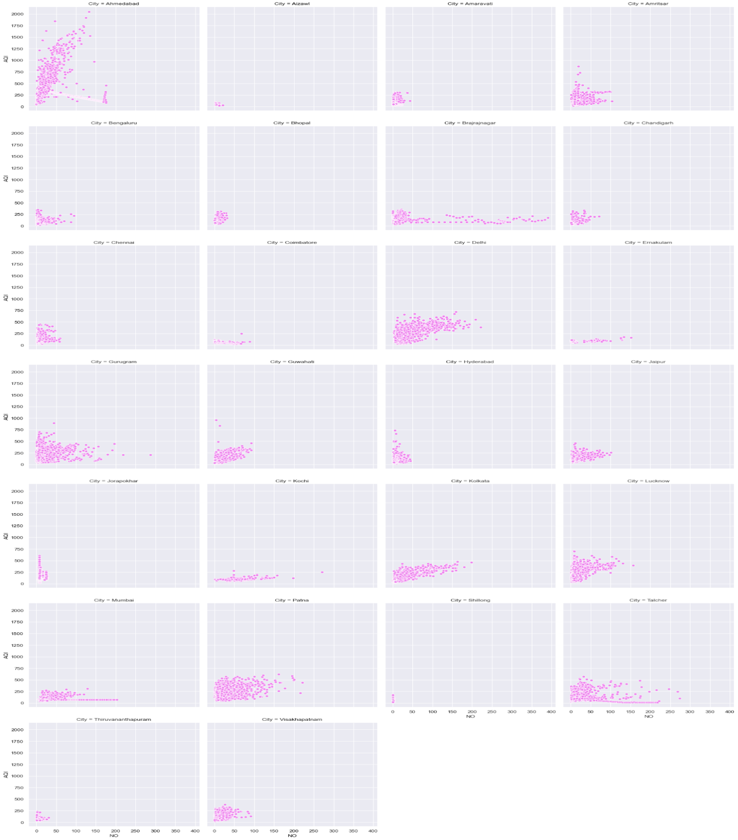

In Amritsar, Talcher is showing a considerable increase in the NO concentration. We can also see that Brajrajnagar is showing a dangerous increase in the NO concentration.

**Nitrogen Dioxide - NO2**

Nitrogen dioxide is part of a group of gaseous air pollutantsproduced as a result of road traffic and other fossil fuel combustion processes. Its presence in air contributes to the formation and modification of other air pollutants, such as ozone and particulate matter, and to acid rain.

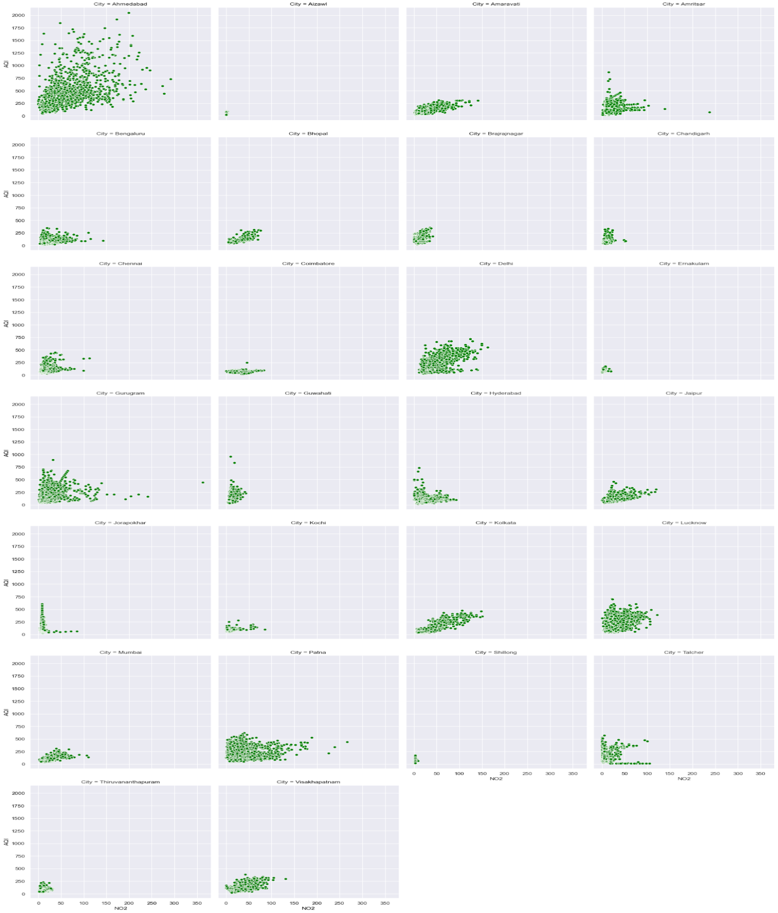

Cities like Patna, Delhi, Amritsar and Ahmedabad show higher amounts of NO2.

**Ammonia - NH3**

Ammonia (NH3) is a highly reactive and soluble alkaline gas. It originates from both natural and anthropogenic sources, with the main source being agriculture, e.g. manures, slurries and fertiliser application.

InChennai we are seeing large concentrations of ammonia and shillong is having almost no presence of it at all.

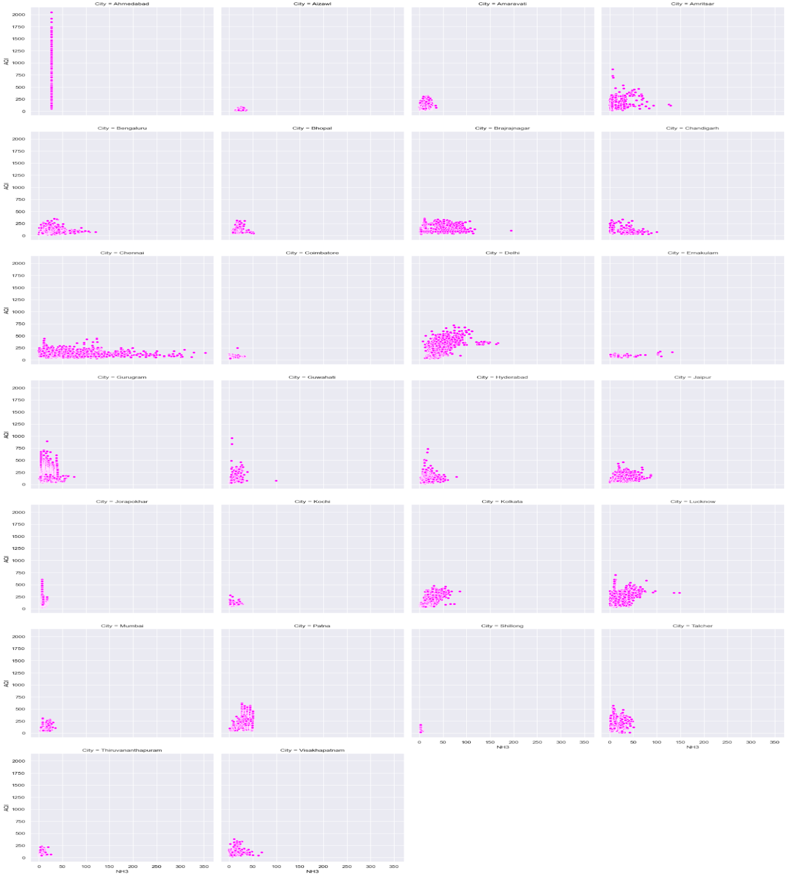

**Carbon Monoxide - CO**

Carbon monoxide (CO) a colorless, odorless, tasteless, and toxic air pollutant is produced in the incomplete combustion of carbon-containing fuels, such as gasoline, natural gas, oil, coal, and wood. The largest anthropogenic source ofCO is vehicle emissions.

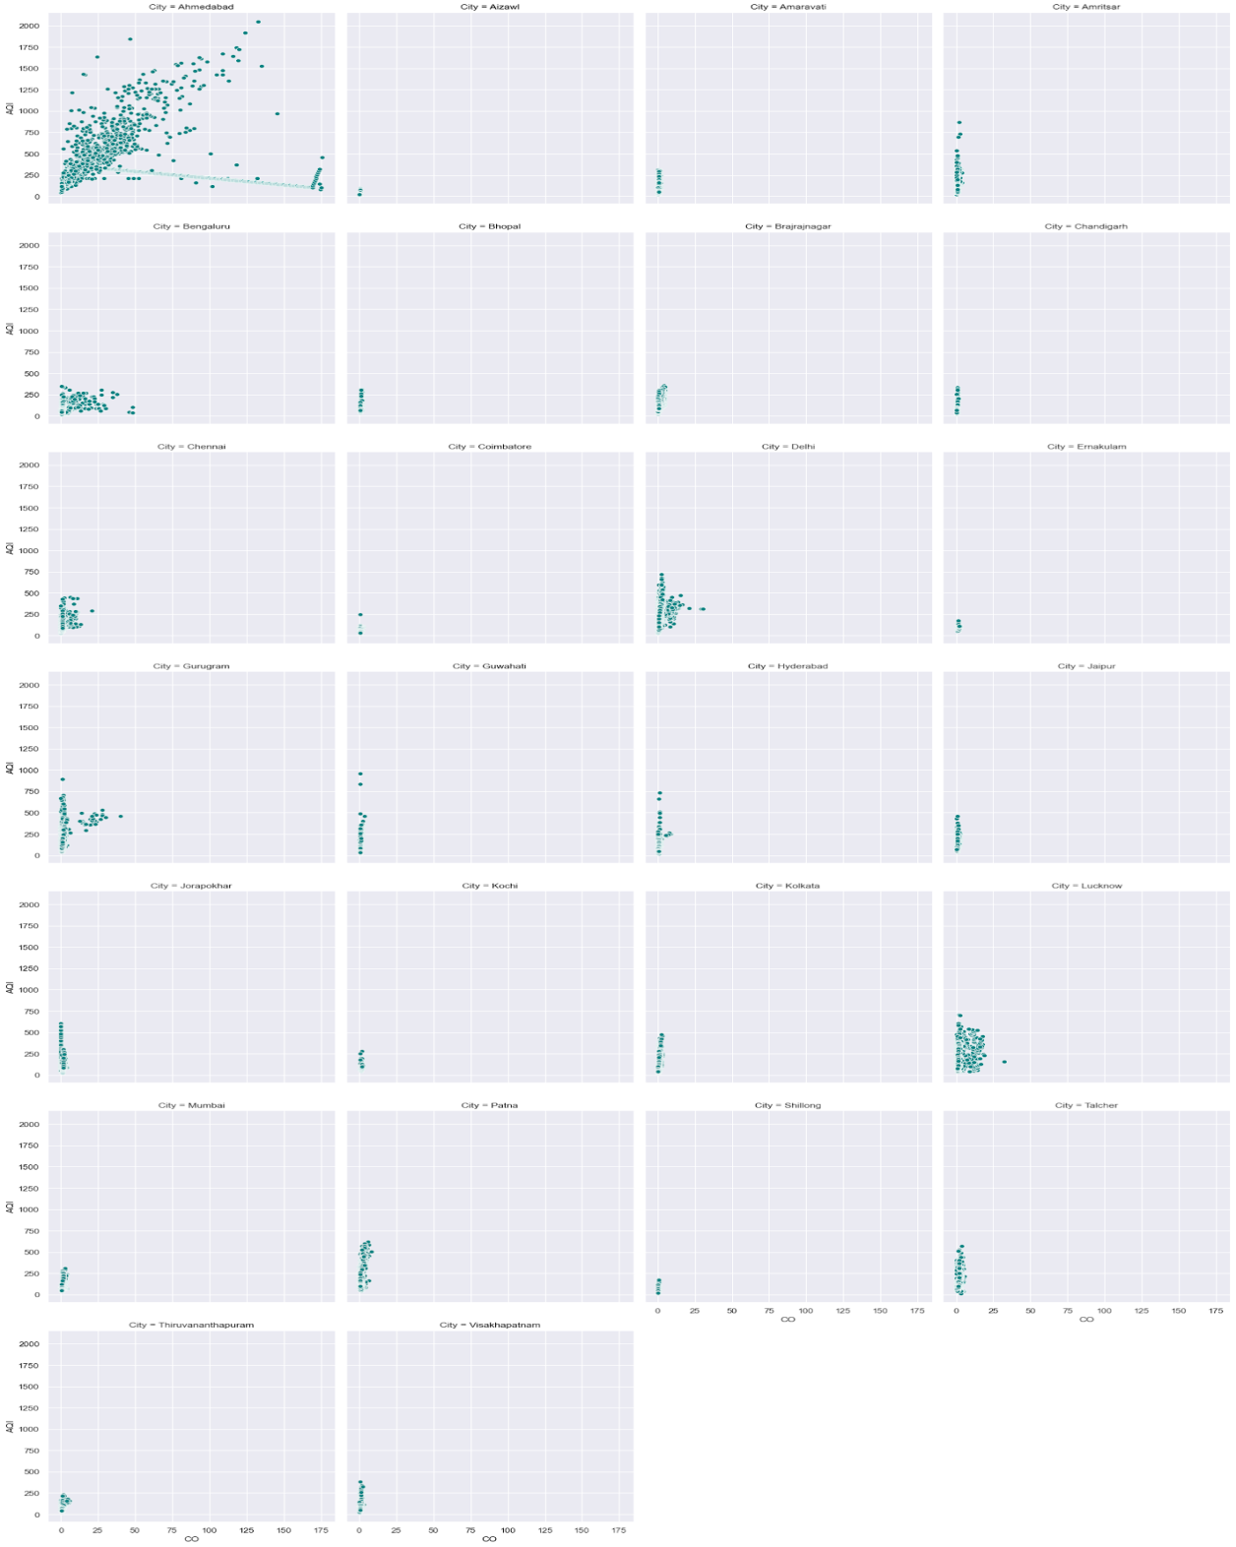

Ahmedabad is the only city showing high concentration of ammonia. We can assume presence of vehicles might be the major source.

**Sulphur Dioxide - SO2**

Sulphur dioxide (SO2), a colorless, bad-smelling, toxic gas, is part of a larger group of chemicals referred to as sulphur oxides (SOx). Secondary pollutants formed with sulphur dioxide include sulphate aerosols, particulate matter, and acid rain.

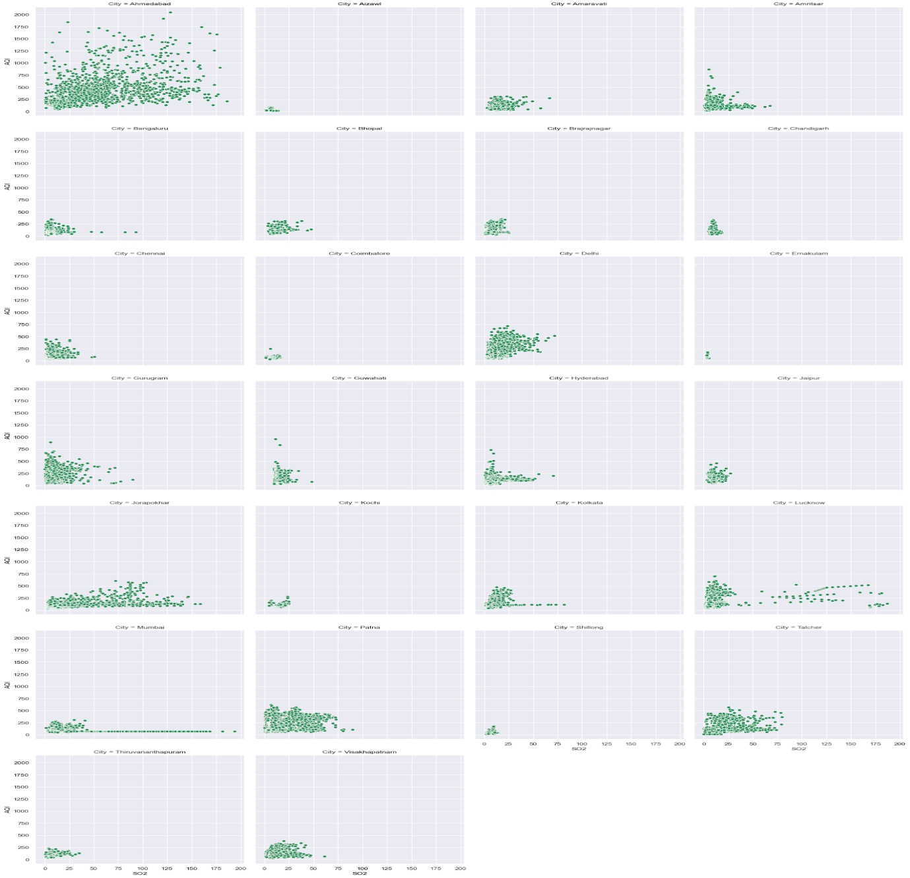

Ahmedabad, Mumbai, Lucknow, Jorapokhar, are showing high sulphur dioxide

**Ozone - 03**

Ozone at ground level is a harmful air pollutant, because of its effects on people and the environment, and it is the main ingredient in smog.

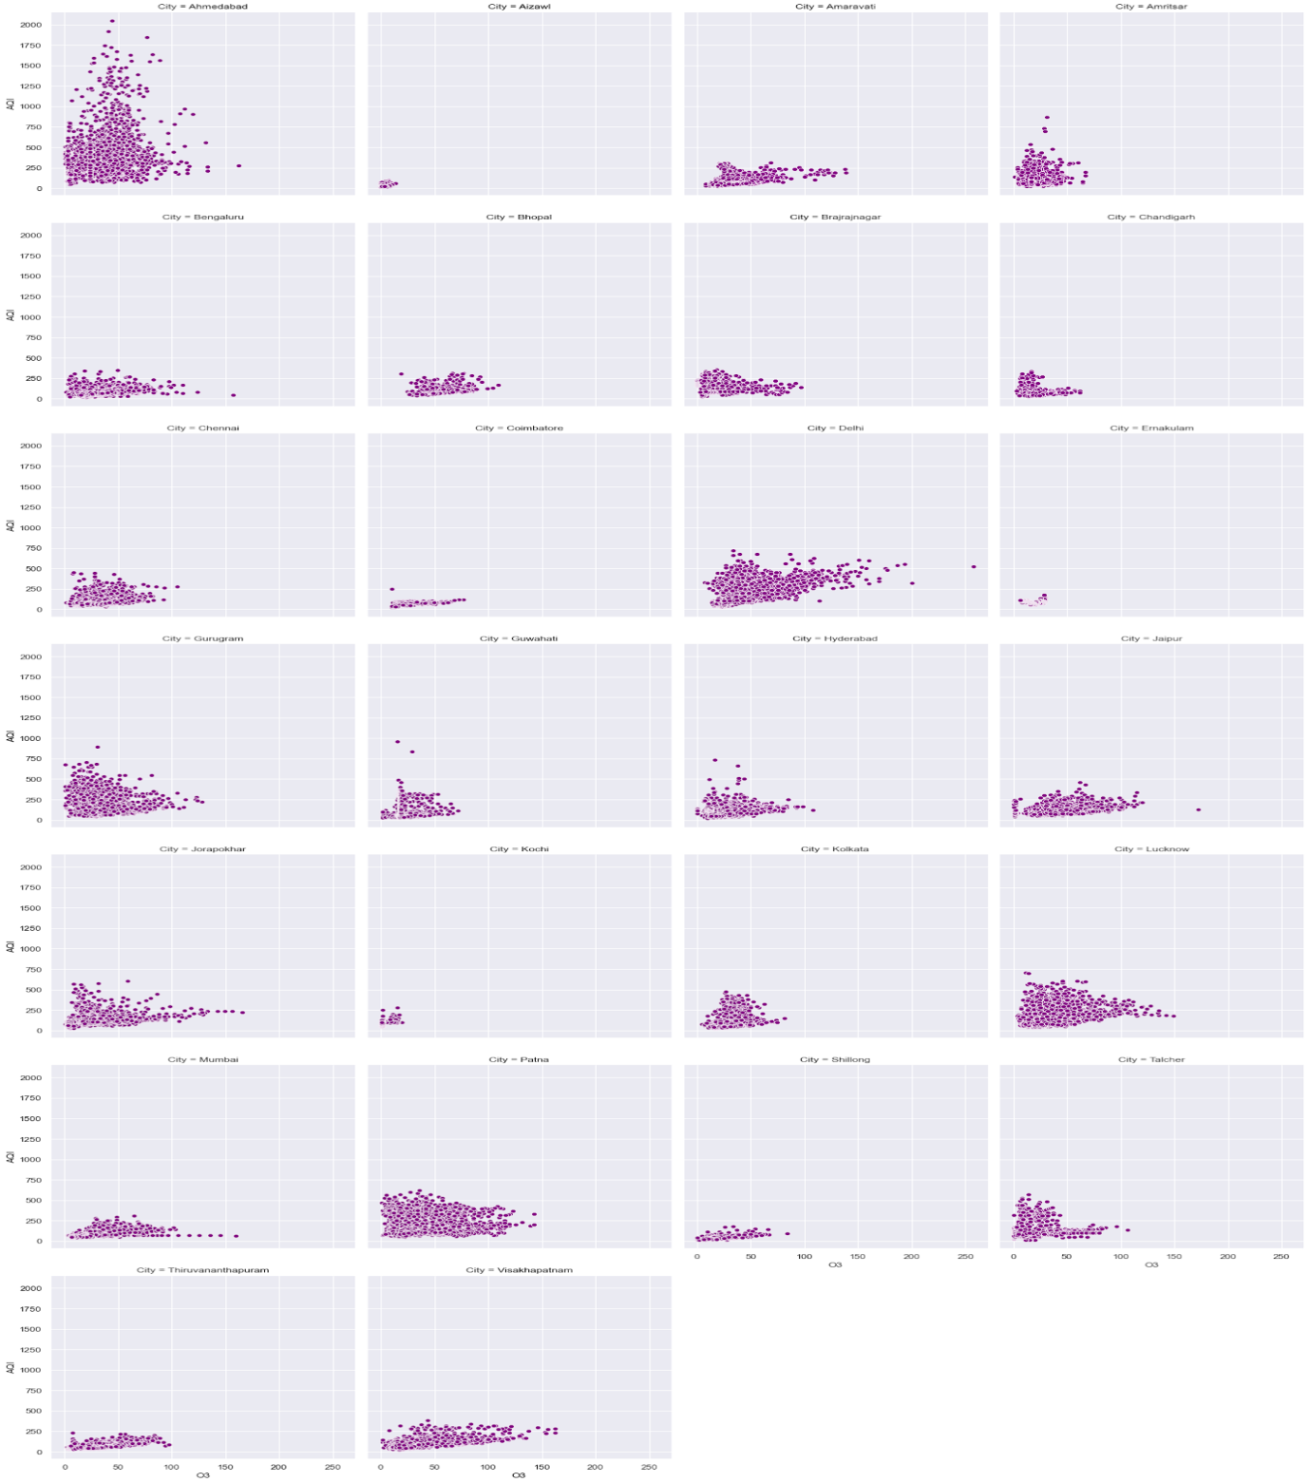

Cities like Vishakapatanam, Lucknow, Jorapokhar, Delhi, Bengaluru and Amaravati are showing higher concentrations of ozone

**4.6.3 Box Plots**

A box plot(also known as box and whisker plot) is a type of chart often used in exploratory data analysis to visually show the distribution of numerical data and skewness through displaying the data quartiles (or percentiles) and averages.It is mainly used for detecting outliers in our data.

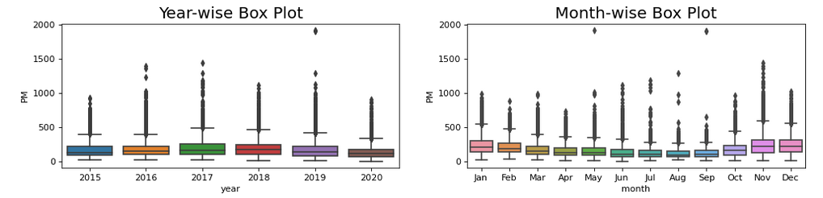

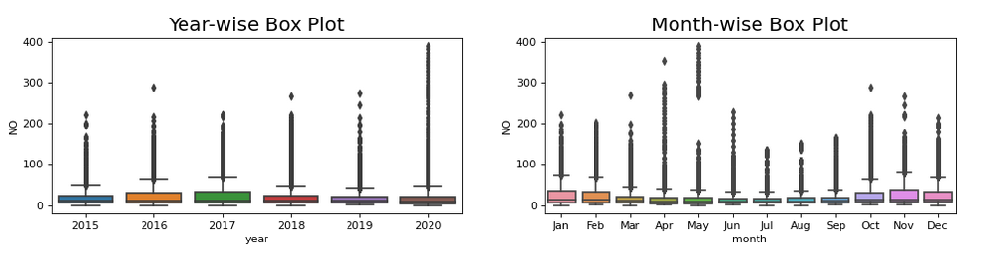

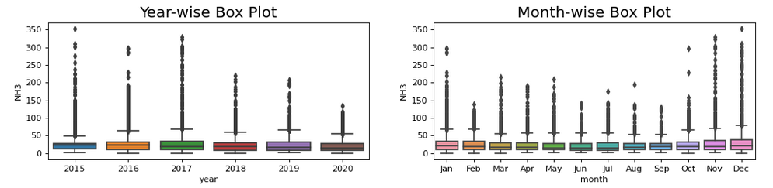

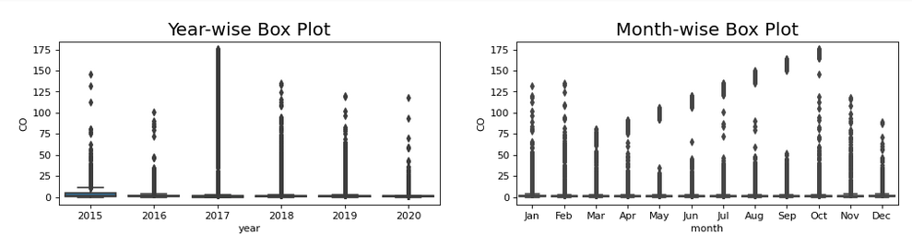

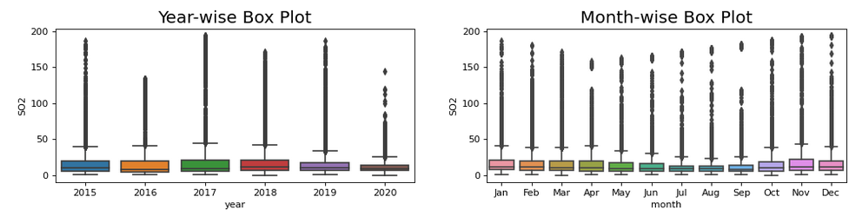

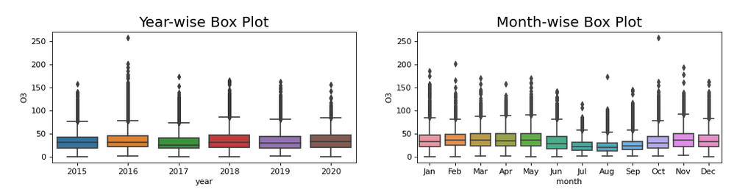

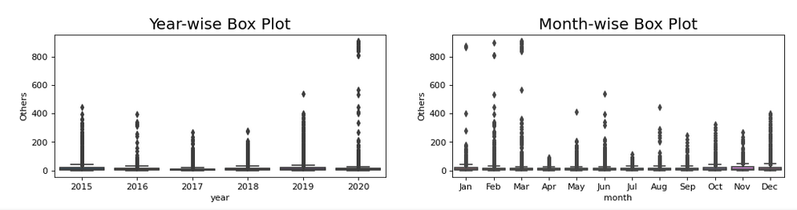

There is a clear trend that pollution level in India falls in the month of July and August. This might be majorly because the monsoon season sets in during these months.The Other pollutants levels additionally show a major decline around April. The pollution level then starts rising and reaches the highest levels in months august-september Again, its during these months that a lot of festivals take place,especially in northern parts of India. SO2 level has started increasing after 2017, although it had also seen a sudden rise in 2015 also. The same pattern is also reflected in other pollutants levels also. The median values of pollutants in 2020 are generally less as compared to other years giving us a sense that there might be a reduction in pollution lately due to the outbreak of covid-19. The pollutant levels remain high in the months jan-april and then starts declining from may-july and then again rise in august - december reaching its peak level.

**4.6.4 Bar Plots**

A barplot is basically used to aggregate the categorical data according to some methods and by default it's the mean. It can also be understood as a visualization of the group by action. To use this plot we choose a categorical column for the x axis and a numerical column for the y axis and we see that it creates a plot taking a mean per categorical column.

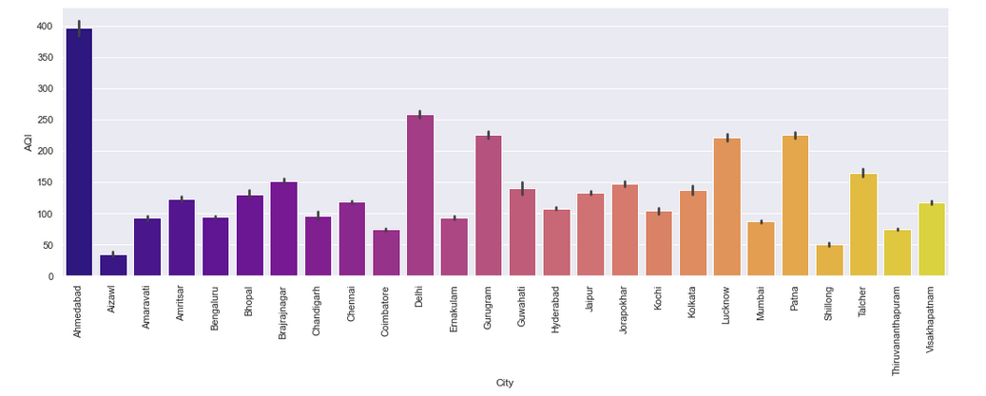

Here we have plotted a bar plot with cities and their mean AQI range. We can see that Ahmedabad is the city with the highest AQI range. That is the air quality can be classified as severe in this region. Aizawl is the region with good air quality. Other than Ahmedabad cities like Delhi, Gurgaon, Lucknow, Patna, Talcher exhibit high AQI whereas cities like Kochi, Shillong, Ernakulam exhibit low AQI compared to Others.

**5. MODEL TRAINING AND EVALUATION**

**5.1 Introduction**

Machine learning consists of algorithms that can automate analytical model building. Using algorithms that iteratively learn from data, machine learning models facilitate computers to [find hidden insights from Big Data](https://www.allerin.com/services/big-data-analytics/hadoop-solutions) without being explicitly programmed where to look. This has given rise to a plethora of applications based on Machine learning.The model building process involves setting up ways of collecting data, understanding and paying attention to what is important in the data to answer the questions you are asking, finding a statistical, mathematical or a simulation model to gain understanding and make predictions.

**5.2 Splitting Data into Train and Test sets**

The procedure involves taking a dataset and dividing it into two subsets. The first subset is used to fit the model and is referred to as the training dataset. The second subset is not used to train the model.

**5.3 Building various Machine learning models**

**Feature scaling (Standardization)**

Standardization is an important technique that is mostly performed as a pre-processing step before many Machine Learning models, to standardize the range of features of input data set. Standardization comes into picture when features of input data set have large differences between their ranges, or simply when they are measured in different measurement units.

* + 1. **Multiple Linear Regression**

Multiple Linear Regression is an extension of Simple Linear regression as it takes more than one predictor variable to predict the response variable.Multiple Linear Regression is one of the important regression algorithms which models the linear relationship between a single dependent continuous variable and more than one independent variable.For MLR, the dependent or target variable(Y) must be the continuous/real, but the predictor or independent variable may be of continuous or categorical form.

Here we are predicting the attribute AQI using MLR algorithm. As a result we get the model with an Mean Square Error of 2430.717224564935 and an RMSE score of 49.302304454913006.

**5.3.2 Logistic Regression**

Logistic Regression is a Machine Learning algorithm which is used for the classification problems, it is a predictive analysis algorithm and based on the concept of probability. The hypothesis of logistic regression tends it to limit the cost function between 0 and 1. In regression analysis, logistic regression (or logit regression) is estimating the parameters of a logistic model (a form of binary regression).

In order to find the best fitted model, we need to take into condition certain parameters including accuracy, precision, recall and f1 score. Accuracy is simply a ratio of correctly predicted observation to the total observations. Precision is the ratio of correctly predicted positive observations to the total predicted positive observations. Recall is the ratio of correctly predicted positive observations to the all observations in actual class - yes. F1 Score is the weighted average of Precision and Recall.

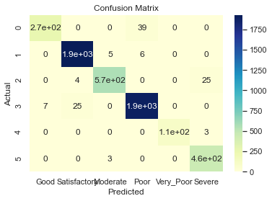

Classification Report:

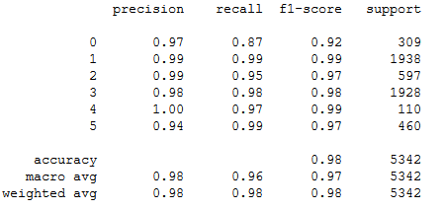

**5.3.3 K Nearest Neighbors (KNN)**

The k-nearest neighbors (KNN) algorithm is a simple, easy-to-implement supervised machine learning algorithm that can be used to solve both classification and regression problems. The KNN algorithm assumes that similar things exist in close proximity. In other words, similar things are near to each other.

In order to obtain the optimum k value we used the Elbow method. We plotted a graph using accuracy and the k values.

The optimum value of k obtained is 6

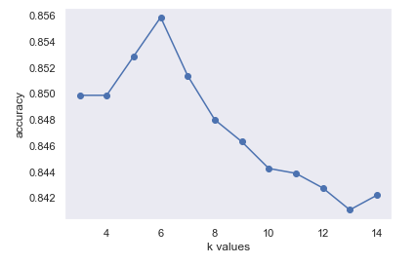

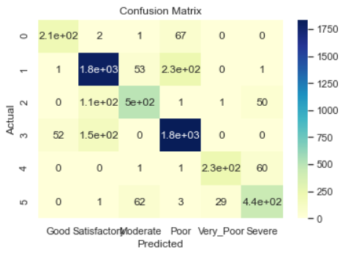

Classification Report

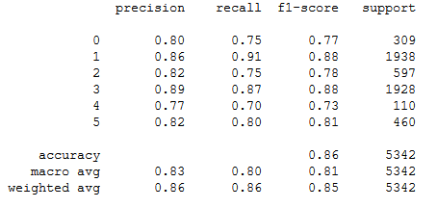

* + 1. **Decision Tree Classifier**

Decision Tree is a Supervised learning technique that can be used for both classification and Regression problems, but mostly it is preferred for solving Classification problems. It is a tree-structured classifier, where internal nodes represent the features of a dataset, branches represent the decision rules and each leaf node represents the outcome.

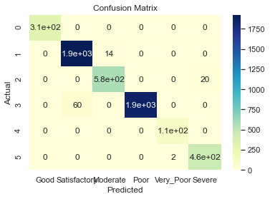

Classification Report

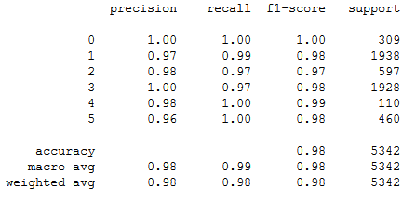

* + 1. **Support Vector Machine (SVM)**

Support Vector Machine or SVM is one of the most popular Supervised Learning algorithms, which is used for Classification as well as Regression problems. However, primarily, it is used for Classification problems in Machine Learning. The goal of the SVM algorithm is to create the best line or decision boundary that can segregate n-dimensional space into classes so that we can easily put the new data point in the correct category in the future. This best decision boundary is called a hyperplane.

SVM can be of two types:

* **Linear SVM**

 Linear SVM is used for linearly separable data, which means if a dataset can be classified into two classes by using a single straight line, then such data is termed as linearly separable data, and the classifier is used as Linear SVM classifier.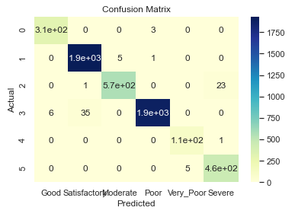

Classification Report

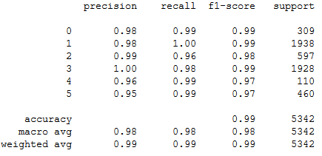

* **Non-linear SVM**

Non-Linear SVM is used for non-linearly separated data, which means if a dataset cannot be classified by using a straight line, then such data is termed as non-linear data and the classifier used is called as Non-linear SVM classifier

**Polynomial SVM**

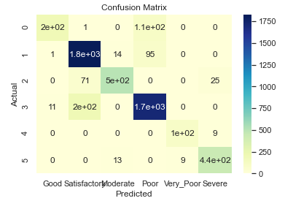

Here degrees are equal to 3.

The classification Report is

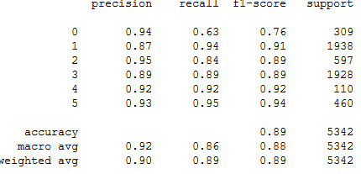

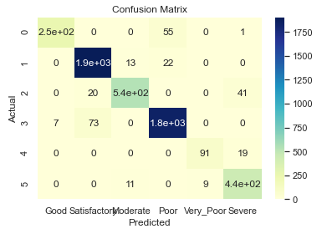 **Radial SVM**

Classification Report

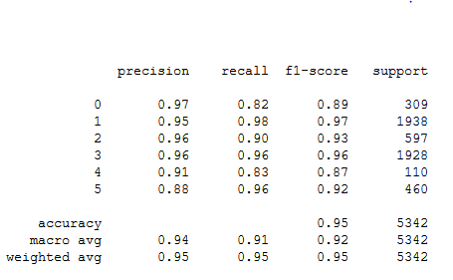

**5.3.6 Random Forest**

Random Forest is a popular machine learning algorithm that belongs to the supervised learning technique. It can be used for both Classification and Regression problems in ML. It is based on the concept of ensemble learning**,** which is a process of combining multiple classifiers to solve a complex problem and to improve the performance of the model.As the name suggests**,** "Random Forest is a classifier that contains a number of decision trees on various subsets of the given dataset and takes the average to improve the predictive accuracy of that dataset."

The greater number of trees in the forest leads to higher accuracy and prevents the problem of overfitting.

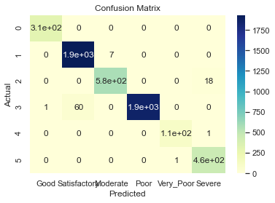

Classification Report

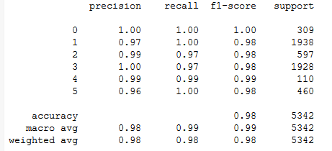

* + 1. **Gradient Boosting Classifier**

Gradient boosting is a machine learning technique for regression and classification problems, which produces a prediction model in the form of an ensemble of weak prediction models, typically decision trees.  It relies on the intuition that the best possible next model, when combined with previous models, minimizes the overall prediction error. The key idea is to set the target outcomes for this next model in order to minimize the error.

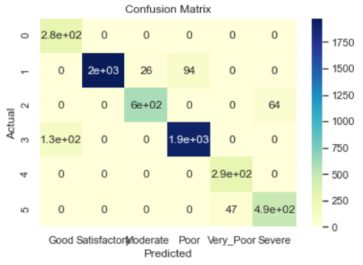

Classification Report

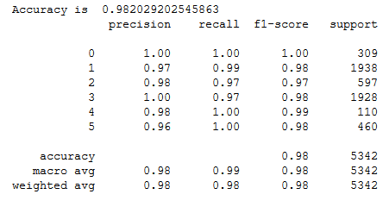

**5.3.8 Extreme Gradient Boosting Classifier**

XGBoost is an implementation of Gradient Boosted decision trees. It is an optimized distributed gradient boosting library designed to be highly efficient**,**flexible andportable. It implements machine learning algorithms under the [Gradient Boosting](https://en.wikipedia.org/wiki/Gradient_boosting) framework. XGBoost provides a parallel tree boosting (also known as GBDT, GBM) that solves many data science problems in a fast and accurate way.

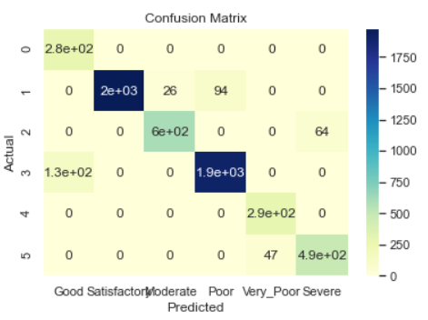

Classification Report

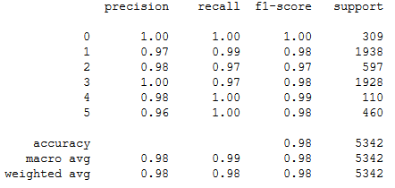

**5.3.9 Naïve Bayes Classifier**

Naïve Bayes algorithm is a supervised learning algorithm, which is based on Bayes theorem and used for solving classification problems. It is mainly used in text classification that includes a high-dimensional training dataset. Naïve Bayes Classifier is one of the simple and most effective Classification algorithms which helps in building the fast machine learning models that can make quick predictions. It is a probabilistic classifier, which means it predicts on the basis of the probability of an object.

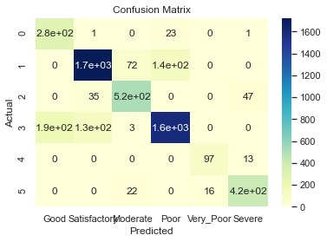

Classification Report

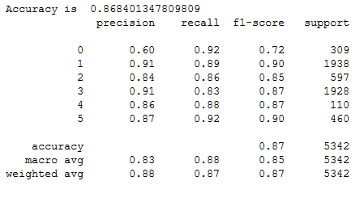

**5.4 Conclusion**

By evaluating the model Multiple Linear Regression for predicting AQI, it gave an MSE value of 6251.51 and an RMSE value of 79.066. By evaluating the above models for predicting AQI Bucket, we found that Decision Tree stood first in model accuracy with 94.48%. Whereas, Naïve Bayes Classifiers have the least accuracy of 98%.

|  |  |  |  |  |
| --- | --- | --- | --- | --- |
| **Model** | **Accuracy** | **Precision** | **Recall** | **F1 score** |
| Logistic Regression | 0.97 | 0.94 | 0.99 | 0.97 |
| KNN | 0.85 | 0.86 | 0.86 | 0.85 |
| Decision Tree | 0.98 | 0.98 | 0.98 | 0.98 |
| SVM(Linear) | 0.98 | 0.99 | 0.99 | 0.99 |
| SVM(Polynomial) | 0.89 | 0.90 | 0.89 | 0.89 |
| SVM(Radial) | 0.94 | 0.95 | 0.95 | 0.95 |
| Random Forest | 0.98 | 0.98 | 0.98 | 0.98 |
| Gradient Boosting | 0.98 | 0.98 | 0.98 | 0.98 |
| Extreme gradient boosting | 0.98 | 0.98 | 0.98 | 0.98 |
| Naive Bayes Classifier | 0.86 | 0.88 | 0.87 | 0.87 |

**6.USER INTERFACE AND WEBSITE HOSTING**

**HOME PAGE**

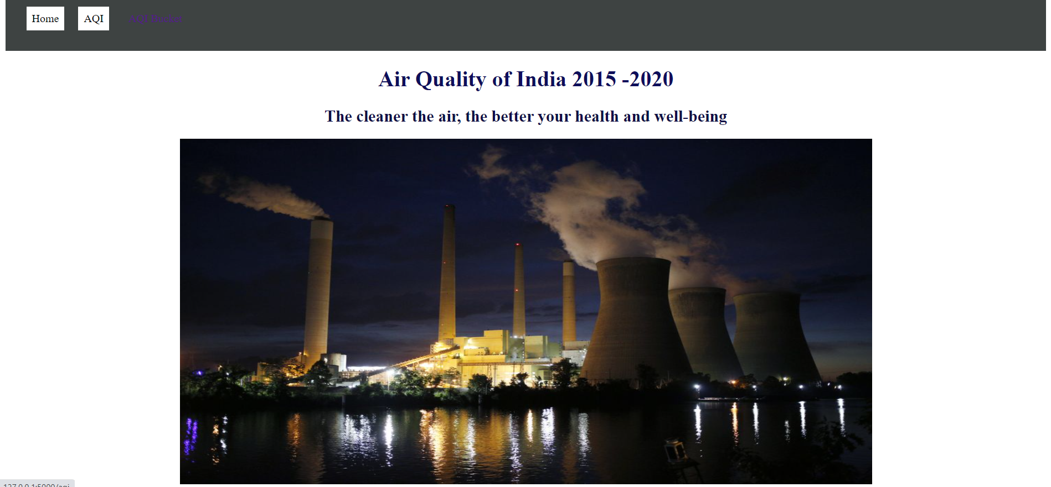

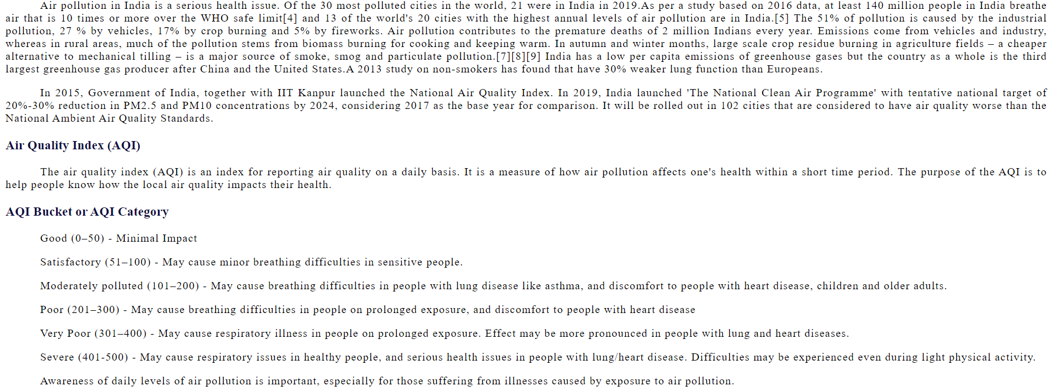

**AQI PREDICTION PAGE**

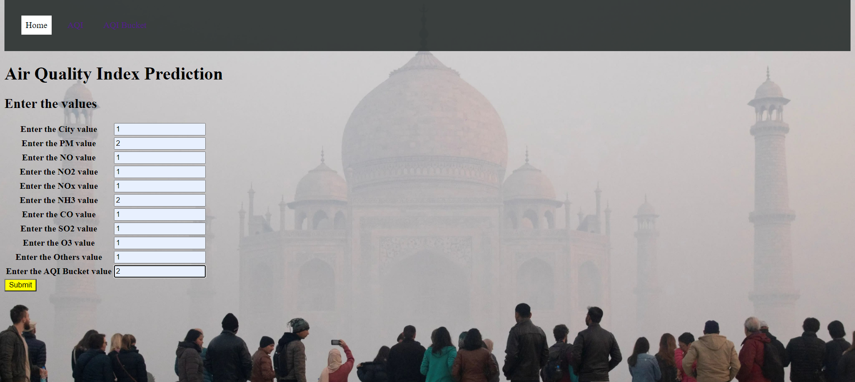

**PREDICTED RESULT PAGE OF AQI**



**AQI BUCKET PAGE**

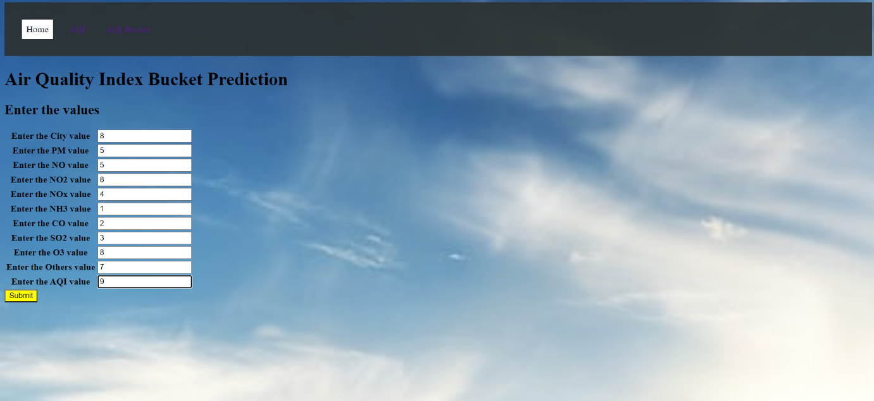

**RESULT PAGE OF AQI BUCKET PREDICTION**



**WEBSITE HOSTING**

The hosted site would be available through <http://anaghasharma.pythonanywhere.com/>

**7. ADVANTAGES, DISADVANTAGES AND FUTURE SCOPES**

**ADVANTAGES**

* Identifies areas having low air exchange rate and less sources of air pollution
* The data collected from air quality monitoring helps us assess impacts caused by poor air quality on public health
* The scenario helps us to identify polluted areas, the level of pollution and air quality level
* It can automatically perform highly accurate source contribution estimation
* Helps to identify the major pollutant in different cities

**DISADVANTAGES**

* Even any slight variations in AQI value can change the label value.
* Atmospheric pollutants like Xylene, Benzene and Toluene are hard to trace which leads to the non recording of the values which in fact play a significant role in the model building.
* If the stations in the cities recording the pollutant measures are in active it will lead to the non availability of data

**FUTURE SCOPE**

* Data mining algorithms could be used to increase the accuracy level in the future work
* We can introduce more meteorological factors like precipitation, minimum and maximum temperature, solar radiation, vapour pressure etc. to increase the accuracy of the system

**8. CONCLUSION**

In this study, we compare the data modelling techniques that are most suitable to predict the Air Quality Index of a region and to categorize these regions based on the air quality labels as Good, Satisfactory,Moderate, Poor, Very poor and Severe. Here the target variable is the Air Quality Index of cities and the label they belong to i.e. AQI and AQI_Bucket respectively. According to the results which were obtained, machine learning models like Decision tree, Linear and polynomial SVM used for multi class classification are the best giving an accuracy close to 98%. We have also developed a multiple linear regression model to predict the Air Quality Index.In addition to this, we can predict the Air Quality Index of cities using the micro web framework flask.

**9. REFERENCES**

[1] U. Mahalingam, K. Elangovan, H. Dobhal, C. Valliappa, S. Shrestha and G. Kedam, "A Machine Learning Model for Air Quality Prediction for Smart Cities," *2019 International Conference on Wireless Communications Signal Processing and Networking (WiSPNET)*, Chennai, India, 2019, pp. 452-457, doi: 10.1109/WiSPNET45539.2019.9032734.

[2] A. Mbarak, Y. Yetis and M. Jamshidi, "Data - Based Pollution Forecasting via Machine Learning: Case of Northwest Texas," 2018 World Automation Congress (WAC), Stevenson, WA, 2018, pp. 1-6, doi: 10.23919/WAC.2018.8430438.

[3] X. Du, F. Zeng, G. Shi and Y. Feng, "Smart Pollution Source Tracing via Gradient Tree Boosting Regression," 2019 International Conference on Machine Learning, Big Data and Business Intelligence (MLBDBI), Taiyuan, China, 2019, pp. 341-344, doi: 10.1109/MLBDBI48998.2019.00077.

[4] C. Srivastava, S. Singh and A. P. Singh, "Estimation of Air Pollution in Delhi Using Machine Learning Techniques," 2018 International Conference on Computing, Power and Communication Technologies (GUCON), Greater Noida, Uttar Pradesh, India, 2018, pp. 304-309, doi: 10.1109/GUCON.2018.8675022.

[5] K. Nandini and G. Fathima, "Urban Air Quality Analysis and Prediction Using Machine Learning," 2019 1st International Conference on Advanced Technologies in Intelligent Control, Environment, Computing & Communication Engineering (ICATIECE), Bangalore, India, 2019, pp. 98-102, doi: 10.1109/ICATIECE45860.2019.9063845.